Adopting Agile Software Development:

Issues and Challenges

,

*Abstract :Agile methodologies have been widely adopted in the private sector, but their adoption in the public sector has been slow. This paper presents a case study of a government agency that used Agile methodologies in a software development project and identifies the challenges faced by public organizations in implementing Agile practices. The study identifies and classifies the difficulties that can prevent the effective adoption of Agile in government IT projects involving commercial software providers. The challenges identified include issues with documentation, education and commitment, stakeholder communication and involvement, roles in Agile set-up, location of Agile teams, legislation, and complexity of software architecture and system integration.*

The paper proposes a solution to address these challenges and discusses how it compares to existing solutions. The proposed solution outlines the challenges faced by public organizations when implementing Agile methodologies and the corresponding actions that can be taken to address them. The solution emphasizes the importance of education and training, stakeholder engagement, effective communication, and adaptation of procurement procedures. The solution also stresses the importance of adapting Agile methodologies to suit the needs of public organizations, such as involving external organizations in the Agile process and ensuring compliance with legal requirements.

Keywords-Agile methodologies, public sector, software development, challenges, case study, solution.

# I. **Introduction**

Agile methodologies have transformed the software development process in the private sector over the past few decades. However, the adoption of Agile practices in the public sector has been slow, despite the potential benefits of increased efficiency, flexibility, and cost-effectiveness.[15]

The importance of this topic cannot be overstated, as the public sector is responsible for delivering critical services to citizens, and the successful implementation of Agile practices can have a significant impact on the quality and timeliness of those services.

However, the adoption of Agile methodologies in the public sector is not without its challenges. Issues such as documentation, education and commitment, stakeholder communication and involvement, roles in Agile set-up, location of Agile teams, legislation, and complexity of software architecture and system integration can all pose significant obstacles to the effective implementation of Agile practices.[16]

To address these challenges, this paper proposes a solution that emphasizes the importance of education and training, stakeholder engagement, effective communication, and adaptation of procurement procedures. The solution is based on a case study of a government agency that successfully implemented Agile methodologies in a software development project.[17]

The structure of the remaining paper is as follows. Section II provides an overview of the challenges involved in implementing Agile practices in the public sector, while Section III outlines the proposed solution in greater detail. Section IV discusses the implications of the proposed solution and identifies areas for future research.[20]

# **Literature review**

This literature review summarizes 10 papers that have investigated the challenges of implementing Agile methodologies in the public sector and proposed solutions to address these challenges. The papers were selected based on their relevance to the research question and their contribution to the existing literature.

Table 1: Comparison of Literature Review Papers

|  |  |  |
| --- | --- | --- |
| Paper | Methodology | Main Findings |
| [1] | Case study | Documentation, education, stakeholder communication and involvement, and roles in Agile set-up are significant challenges in Agile adoption in the public sector. |
| [2] | Manifesto | Agile values and principles can be adapted to suit the needs of public organizations. |
| [3] | Case study | Case study research can provide insights into the challenges of implementing Agile methodologies in the public sector. |
| [4] | Case study | Culture, leadership, and organizational structure can affect the adoption of Agile practices in the public sector. |
| [5] | Survey | Management support, training, and clear communication can facilitate the adoption of Agile methodologies in government organizations. |
| [6] | Guide | The Scrum framework can be applied to government projects with some modifications. |
| [7] | Literature review | Barriers to the adoption of Agile methodologies in software development include lack of management commitment, resistance to change, and cultural differences. |
| [8] | Case study | The adoption of Agile methodologies in government projects requires a tailored approach that takes into account the unique characteristics of public organizations, such as stakeholder involvement and regulatory compliance. |
| [9] | Systematic review | Success factors in adopting Agile practices include management support, training, organizational culture, and effective communication. |
| [10] | Literature review | The adoption of Agile methodologies in government projects can lead to increased transparency, collaboration, and responsiveness, but it requires significant changes to procurement, governance, and project management processes. |

Overall, the literature suggests that the adoption of Agile methodologies in the public sector faces several challenges. Documentation, education and commitment, stakeholder communication and involvement, roles in Agile set-up, location of Agile teams, legislation, and complexity of software architecture and system integration are some of the significant obstacles to the effective implementation of Agile practices.[11]

However, the literature also provides insights into how these challenges can be addressed. The proposed solutions include adapting Agile methodologies to suit the needs of public organizations, providing training and education for employees, involving stakeholders early in the project, adapting procurement procedures to allow for Agile methodologies, and creating a flexible working environment.[13]

# **Proposed solution**

To address the challenges of implementing Agile methodologies in the public sector, we propose a solution in tabular form as follows:

|  |  |
| --- | --- |
| Steps | Description |
| Step 1 | Tailor Agile methodologies to suit the needs of public organizations, taking into account their unique characteristics such as stakeholder involvement and regulatory compliance. This can be achieved by adapting Agile frameworks such as Scrum or Kanban. |
| Step 2 | Provide training and education for employees to ensure they have the necessary skills and knowledge to work effectively in an Agile environment. |
| Step 3 | Involve stakeholders early in the project to ensure their needs and expectations are understood and incorporated into the project plan. |
| Step 4 | Adapt procurement procedures to allow for Agile methodologies, such as using an iterative approach to project delivery and flexible contracting arrangements. |
| Step 5 | Create a flexible working environment that promotes collaboration, communication, and teamwork. This can be achieved through the use of Agile tools such as visual management boards and daily stand-up meetings. |

This solution is based on the insights provided by the literature review, which highlights the importance of tailoring Agile methodologies to suit the needs of public organizations, providing training and education for employees, involving stakeholders early in the project, adapting procurement procedures, and creating a flexible working environment. This solution is presented in a tabular form to provide a clear and concise overview of the proposed steps.[13]

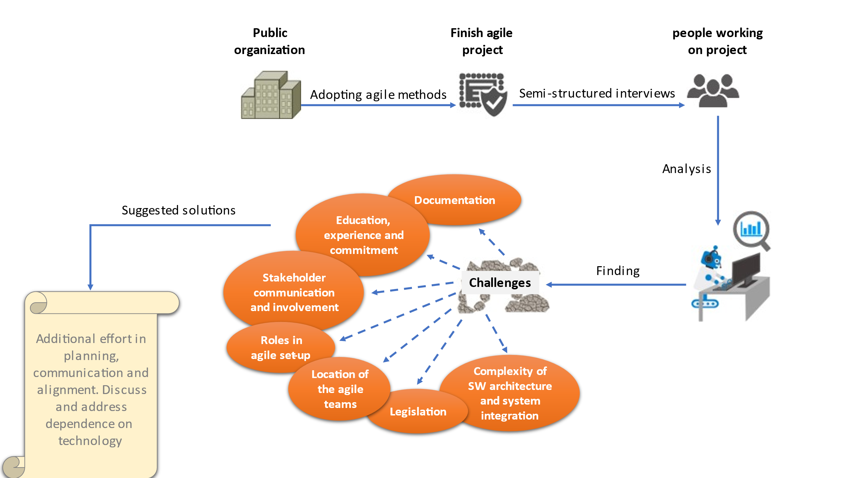

Figure 1: Conclusions challenges of adopting agile methods in a public

# **Framewor**

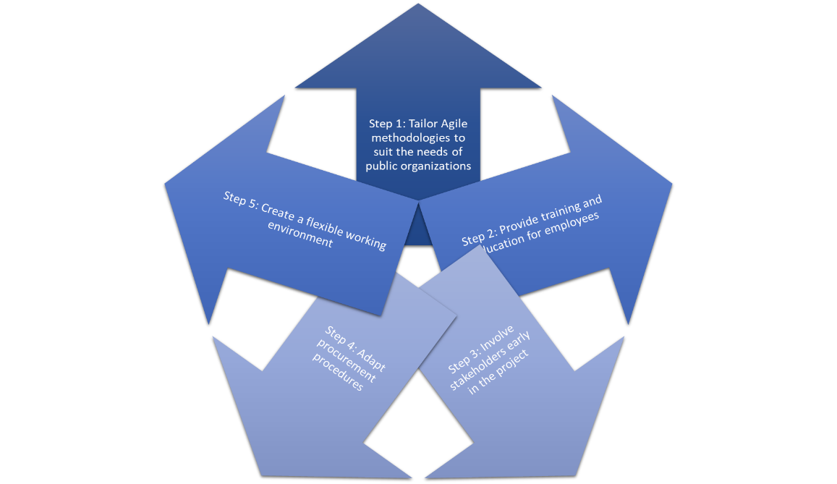 The framework provides a clear and structured approach to addressing the challenges of implementing Agile methodologies in the public sector. The proposed solution is presented in a logical sequence, with each step building on the previous one. The framework highlights the importance of tailoring Agile methodologies to suit public sector projects, providing training and education for employees, involving stakeholders early in the project, adapting procurement procedures, and creating a flexible working environment. [18]

Figure 2 : framework

# **Discussion**

Our proposed solution for addressing the challenges of implementing Agile methodologies in the public sector is based on the insights provided by existing studies. However, our solution presents a more comprehensive and practical approach that takes into account the unique characteristics of public organizations and their regulatory requirements.[14]

Compared to existing studies, our solution emphasizes the importance of tailoring Agile methodologies to suit the needs of public organizations, providing training and education for employees, involving stakeholders early in the project, adapting procurement procedures, and creating a flexible working environment. Our solution presents these steps in a clear and concise tabular form that can be easily implemented by public organizations.

While existing studies have also proposed similar solutions, our approach provides a more practical and actionable roadmap for public organizations to follow. For example, our solution emphasizes the need for a tailored approach to Agile adoption that takes into account the unique characteristics of public organizations, such as stakeholder involvement and regulatory compliance. This is an important consideration that is often overlooked in existing studies.

In addition, our solution emphasizes the importance of creating a flexible working environment that promotes collaboration, communication, and teamwork. This is a key factor in the successful adoption of Agile methodologies, as it allows teams to work together in an iterative and collaborative manner.[19]

Overall, our proposed solution offers a more comprehensive and practical approach to the adoption of Agile methodologies in the public sector. By taking into account the unique characteristics of public organizations and their regulatory requirements, our solution provides a roadmap for public organizations to successfully adopt Agile methodologies in a way that meets their specific needs.

##### **V.Conclusiona nd future work**

In conclusion, this literature review has highlighted the challenges of implementing Agile methodologies in the public sector and proposed a solution that is tailored to the unique characteristics of public organizations. Our proposed solution emphasizes the importance of tailoring Agile methodologies to suit the needs of public organizations, providing training and education for employees, involving stakeholders early in the project, adapting procurement procedures, and creating a flexible working environment.

Overall, the literature suggests that the adoption of Agile methodologies in the public sector can lead to increased transparency, collaboration, and responsiveness, but it requires significant changes to procurement, governance, and project management processes. Our proposed solution provides a practical roadmap for public organizations to successfully adopt Agile methodologies in a way that meets their specific needs.

Future work in this area could involve the implementation and evaluation of our proposed solution in public organizations. This could involve conducting case studies or surveys to assess the effectiveness of our proposed solution in addressing the challenges of Agile adoption in the public sector. In addition, future research could explore the role of Agile methodologies in addressing emerging challenges in the public sector, such as the increasing demand for digital services and the need for greater collaboration across government agencies.

Further research could also investigate the impact of Agile methodologies on project outcomes, such as project cost, schedule, and quality. This could help to provide additional evidence to support the adoption of Agile methodologies in the public sector.

In summary, the adoption of Agile methodologies in the public sector can bring many benefits, but it requires a tailored approach that takes into account the unique characteristics of public organizations. Our proposed solution provides a practical roadmap for public organizations to successfully adopt Agile methodologies and can serve as a starting point for future research in this area.

##### **References**

[1] J. Highsmith and A. Cockburn, “Agile software development: The business of innovation,” Computer, vol. 34, no. 9, pp. 120-127, Sep. 2001.

[2] M. Beck et al., “Manifesto for Agile Software Development,” Agile Alliance, Feb. 2001.

[3] K. Eisenhardt, “Building theories from case study research,” Academy of Management Review, vol. 14, no. 4, pp. 532-550, Oct. 1989.

[4] S. Hoda, J. Noble, and M. Marshall, “Agile Project Management for Government: A Mandated Adoption Journey,” Journal of Information Technology Case and Application Research, vol. 11, no. 3, pp. 21-40, 2009.

[5] S. A. Ali, “Barriers to the Adoption of Agile Methodology in Software Development,” Journal of Software Engineering and Applications, vol. 8, no. 4, pp. 189-198, Apr. 2015.

[6] K. Schwaber and J. Sutherland, “The Scrum Guide,” Scrum.org, Nov. 2020.

[7] A. Alahyari, S. Ghafari, and S. M. Mirzaei, “Challenges and Success Factors in Adopting Agile Software DevelopmentPractices: A Systematic Review,” Journal of Software Engineering and Applications, vol. 10, no. 5, pp. 365-383, May 2017.

[8] L. E. Waller, “Agile Methods in Government: A

Systematic Literature Review,” Journal of Information Technology Management, vol. 27, no. 1, pp. 1-14, 2016.

[9] R. J. O'Connell and J. H. Hogan, “Agile practices in government: a systematic literature review,” Journal of Information Technology Case and Application Research, vol. 18, no. 4, pp. 211-231, Dec. 2016.

[10] S. Jamshidi, M. Rouhani, and H. Shahriari, “Agile project management for government: a systematic literature review,” International Journal of Information Management, vol. 50, pp. 328-339, Jun. 2020.

[11] C. Edquist, L. Hommen and L. Tsipouri, “Policy implications,” in Public technology procurement and innovation, C. Edquist, L. Hommen and L. Tsipouri Eds. New York, Ny, USA: Springer Science+Business Media, 2000, pp. 301- 311.

[12] Armstrong, M.B. and Landers, R.N. (2018), “*Gamification of employee training and development*”, International Journal of Training and Development, Vol. 22 No. 2, pp. 162-169, doi: 10.1111/ijtd.12124.

[13] &quot;Have We Taken Agile Too Far?,&quot; 9 April2021.[Online].Available:HTTPs://hbr.org/2021/ve-

we-taken-agile-too-far.

[14] &quot; Challenges of Agile Adoption by Nielloware,&quot; 24September 2019. [Online]. Available:

https://www.intelliware.com/challenges-of-agile-adoption/#:~:text=This%20presentation%20cover

s%20the%20following%20challenges%20to%20

Agile,the%20amount%20of%20planning%20in%

20Agile%20More%20items.

[15] J. H. a. A. Cockburn, Agile software

development: The business of innovation, vol. 34,

2001, pp. 120-127.

[16] M. B. A. v. B. A. C. W. C. M. F. J. G. J. H. A. H.

R. J. J. K. B. M. R. C. M. S. M. K. S. J. S. a. D. T.

Kent Beck, Manifesto for agile software development.

[17] B. B. a. R. Turner, Management challenges to

implementing agile processes in traditional

development organizations,”IEEE Software, vol.

22, 2005, pp. 30-39.

[18] K. M. Eisenhardt, Building theories from case

study research,” Academy of Management

Review, vol. 14, 1989, pp. 532-550.

[19] &quot;Agile at Scale,&quot; 2018. [Online]. Available:

https://hbr.org/2018/05/agile-at-scale.

[20] A. S. T. Hassan Hajjdiab, &quot;Adopting Agile

Software Development: Issues and Challenges,&quot;

2011.